**Subject Brainstorm, Thursday March 12th, 2015**

In the brainstorm session of this afternoon it was our goal to find a direction for the company and industry we wanted to analyse in this course.

We very quickly agreed that the direction we wanted to go was in an upcoming sector: the Internet of Things, or shortly: IoT.

As this is a very broad sector with many small start-ups, emerging ideas and opportunities we had to narrow this down a little.

Our brainstrom passed many categories of which a few are listed below:

* Smart environmental monitoring technology
  + Weather monitoring
  + Monitoring of earthquakes
  + Monitoring of tidal movement
  + Monitoring of Glacier depletion
* Smart governmental monitoring technology
  + Monitoring of radiation
  + Monitoring of chemical pollution
  + Monitoring of water pollution
  + Monitoring and organisation of traffic congestion
* Smart personal monitoring
  + Medical recording
  + Sports recording
  + Food intake monitoring
  + Monitoring of pets
  + Home monitoring
  + Energy use recording

Finally our choice has been for Home and Energy monitoring in the form of the Smart Home market. The scope of our analysis will include smart homes that are energy neutral, the so called self sufficient homes. We believe this is a growing an promising sector for future generations and by studying the possibles strategies for companies in this sector, we hope to build for a greener future.

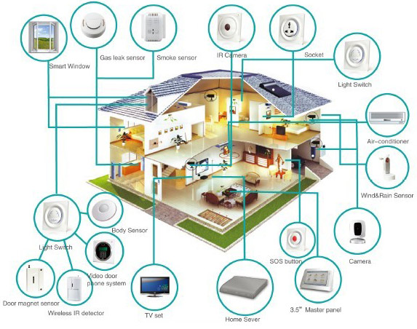­­

Figure 1. Smart home, source: <http://smarthomeenergy.co.uk/what-smart-home>

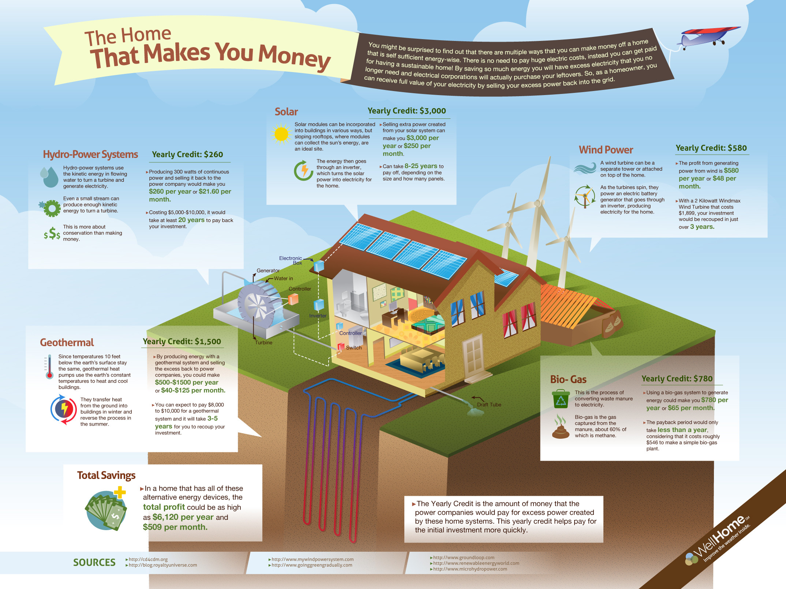

Figure 2. Self-sufficient home, source: <http://tinyhomeart.com/tag/self-sufficient-home>